User Experience Assessment on the IBI Kesatuan Website using the System Usability Scale (SUS)

1nd Kevin Husodo

*Computer Science School of Computer Science Bina Nusantara University* Malang, Indonesia 65154 [kevin.husodo@binus.ac.id](mailto:kevin.husodo@binus.ac.id)

2nd Anasthasya Ivani Trishardiono

*Computer Science School of Computer Science Bina Nusantara University* Malang, Indonesia 65154

[anasthasya.trishardiono@binus.ac.id](mailto:anasthasya.trishardiono@binus.ac.id)

3rd Sebastian Haryo Pradipta

*Computer Science School of Computer Science Bina Nusantara University* Malang, Indonesia 65154

[sebastian.panjisasongko@binus.ac.id](mailto:sebastian.panjisasongko@binus.ac.id)

**Abstract—IBI Kesatuan website provides info on business & tech. Good website design is important for user experience & product quality ratings. Design should be simple, clear, & appropriate. Interaction design has 5 dimensions: words, visual representation, physical objects/space, time, & behavior. User experience can be measured using SUS method.The research uses the SUS method, consisting of 10 questions to determine software usefulness. Validity and reliability tests are conducted using expert review, product-moment coefficient, and Crombach Alpha test. Validity is determined by comparing t(count) with t(table), while reliability is determined using Crombach Alpha test with a range of 0.7-0.9. Variance is calculated using specific formulas.This study used the System Usability Scale (SUS) questionnaire to measure the usability of the IBI Kesatuan website. The validity and reliability of the questionnaire were confirmed, and the overall SUS score obtained from the respondents was 77, indicating "good" usability. The website is acceptable for use and has a positive Net Promoter Score (NPS).The SUS method was used to measure the usability level of the IBI Unitary website, with a score of 77.08 obtained from respondents. This score can identify the website''s strengths and weaknesses, which can be used to improve its design, content, navigation, and other elements to enhance user satisfaction.**

***Keywords—IBI Kesatuan, user experience, SUS method, Crombach Alpha test.***

1. INTRODUCTION

The website that we often use is a collection of several web pages containing information and the results of technological developments that can be accessed by anyone. This website has certainly become familiar and commonly used. On a website, not only text is displayed, but it can also show images, videos, audio, or animations that are interesting to make users feel interested and comfortable when using the website. Websites also help spread information quickly and widely, and can be accessed from anywhere and by anyone. Certainly, with these advantages, it has an important role in helping in the world of education. According to the APJII survey in 2023, there has been an increase in the penetration rate of internet usage for searching information due to Covid-19 in the male population from 2022-2023 by 79.32% of the total male population and in the female population by 77.36% of the total female population. Therefore, indirectly the role of websites is very helpful for the development of information in the future. Especially in the world of education that can be accessed from a distance to make it easier to gather information with a website. One of them is the website originating from IBI Kesatuan. Are there any benefits of the IBI Kesatuan website related to technological advancements in the world of education?

IBI Kesatuan stands for Institute of Business and Informatics Kesatuan, located in Bogor city. This institute operates in the fields of business and information technology, which can be a strong reference for us to face the rapid development of the world in the future. In this advanced development, we do not necessarily have to go to the campus to seek information about it. With the advancement of information technology, various institutions have official websites that can be used to find various information about the things we want to know regarding the institution. An example is the website of IBI Kesatuan, which is [http://www.ibik.ac.id,](http://www.ibik.ac.id/) where users can use it to search for all information about the Institute of Business and Technology Kesatuan without requiring extra effort and time wasted on a trip to the location. On this website, users can find information such as the facilities available at the institute, the faculties offered, and contact persons to reach out to the institute.

On a website, of course there are supporting elements to make it look good, comfortable, and attractive to users. Users will certainly judge and criticize how the design and features are provided, hoping that the website is always updated and developed according to user needs. The purpose of this study is to look at user experiences on the website regarding various aspects or elements such as usefulness, content, navigation, and design. In addition, this research aims to identify the strengths and weaknesses of the website. Of course, in this study, we need respondents who come from users of the website to help fill out the survey that includes questions about their experience using the website. Can the experiences of the respondents have an impact on measuring the usability level based on the SUS method?

1. LITERATURE REVIEW
2. *User Experience (UX)*

User experience, which can be defined as the user's experience when using digital products, is one of the ways of interaction. In this digital world, there are many things or products being offered. The products offered to users are expected to make work easier or simplify a task. Users will share their experiences in the form of satisfaction ratings after using the product. They will review the product's strengths and weaknesses. This can certainly affect the quality rating.

As we know, user experience cannot be separated from design. Design is the first thing that users see when they use a product. With good design, users will feel comfortable when using the product. Usually, a good design is simple and easy to use. From this, we can see that there is also

interaction design. Good design, of course, has several criteria to meet the requirements. According to Kevin Silver, there are five dimensions in the interaction design framework. Here are the five frameworks introduced by Kevin Silver:

* 1. Words : The words used in design should use simple language so that they are easily understood.
  2. Visual Representation : This visual representation certainly includes images, typography, and icons that make it more attractive but do not confuse users.
  3. Physical Objects or Space : In this dimension, there are things that we need to ensure, such as what platform is used for interaction.
  4. Time : Motion and sound become important elements to attract attention. If the duration of user interaction with the product is prolonged, two opinions may arise, which are either the product is attractive or the user experiences difficulties.
  5. Behavior : This dimension involves actions and reactions that can elicit feedback from the user.

1. Institut Bisnis & Informatika Kesatuan (IBI Kesatuan)

IBI Kesatuan is one of the higher education institutes located in Bogor, West Java. This institute offers various study programs in the fields of business and information technology, such as accounting, business management, information technology, and tourism. The institute has designed its curriculum and prepared its students to have the foundation and knowledge needed in the business and information technology world in the future. With the vision of becoming an excellent and quality institute in the fields of business, information technology, and tourism by prioritizing moral and ethical values, it can be understood that the institute aims to produce excellent generations equipped with moral and ethical standards.

As we know, with the world becoming more advanced, we are required to keep up with its developments. Information technology and digitalization will influence human aspects in the fields of business and economy in the future. In this increasingly advanced world, the fields of business and economy will always relate to several advanced technologies to facilitate work. Through its study programs, IBI Kesatuan prepares its students to become future leaders who are able to utilize technology and digitalization to increase productivity in the business world and company competitiveness. In its efforts to expand and facilitate access to information, the institute has a website that can share various information about the institute that can be accessed by anyone, whether it's a student or a prospective student who wants to register or find out about the institute. We can see that the website has a simple and user-friendly design, such as icons for information about the institute, what faculties are available, what facilities are available, and of course, there is a link to fill out user satisfaction.

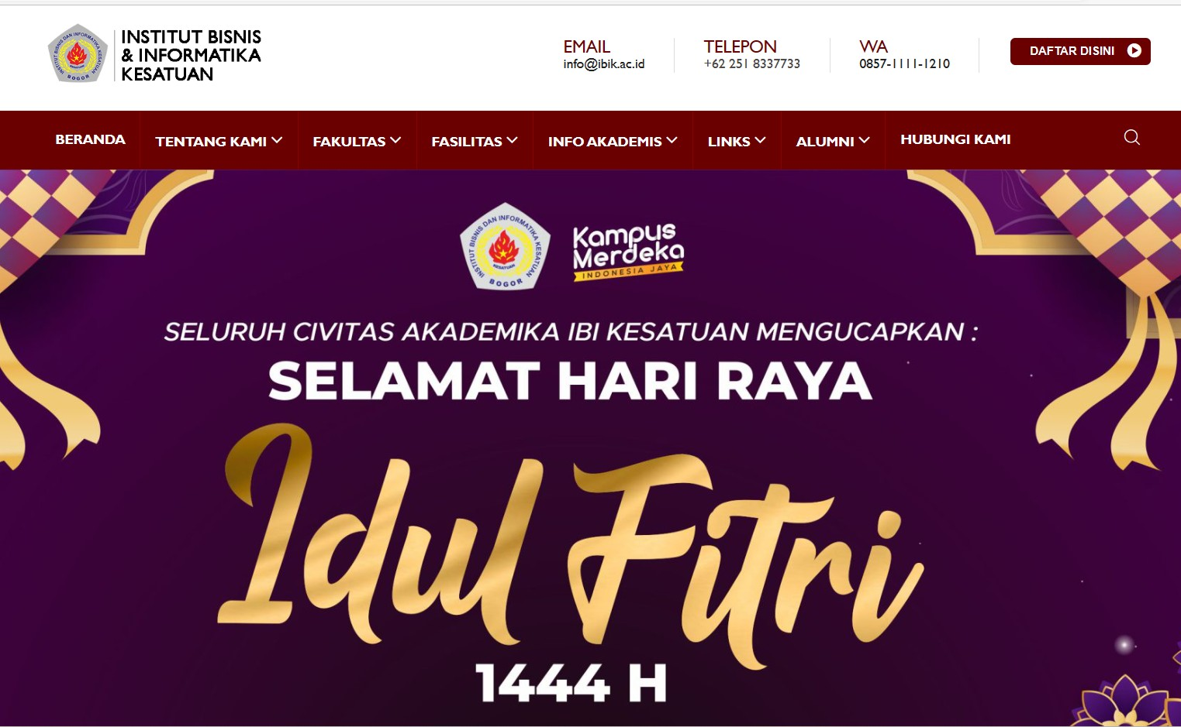

Fig. 1. *Home page*

Figure 1 is the main of the website where there are icons with keywords to open further information.

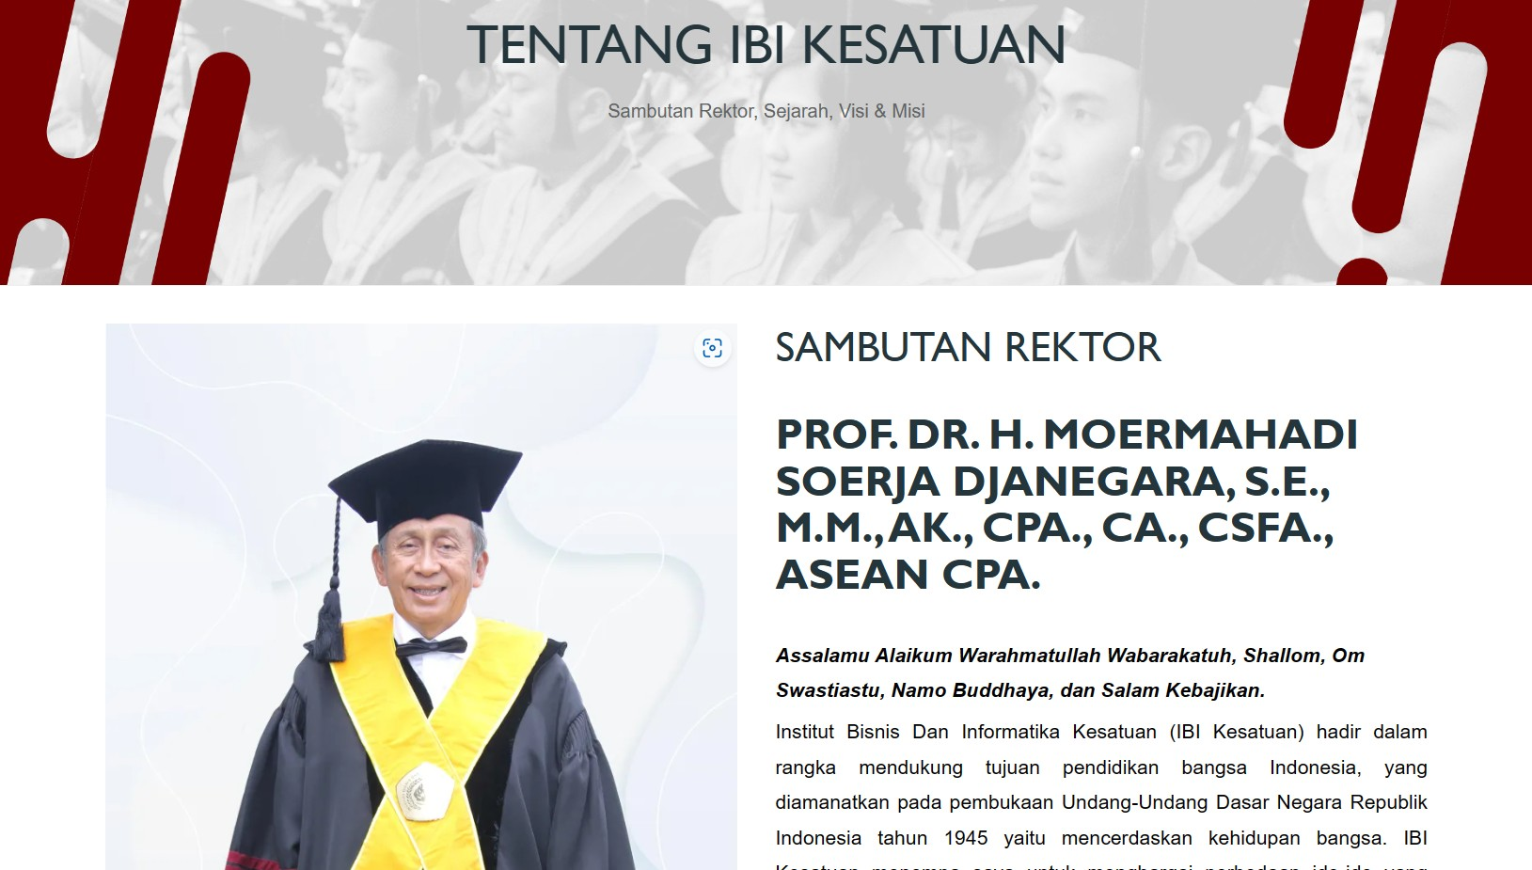

Fig. 2. *About institutes page*

Figure 2 is a welcome message from the rector, history, vision, mission, and map.

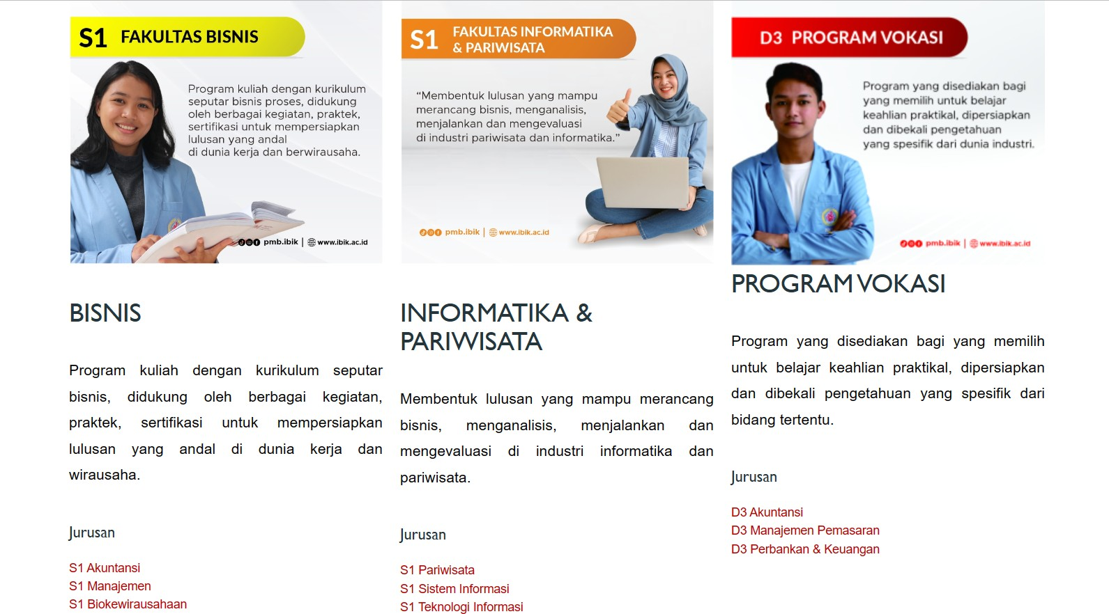

Fig. 3. *Faculty page*

Figure 3 there are various types of study programs that can be taken by prospective students.

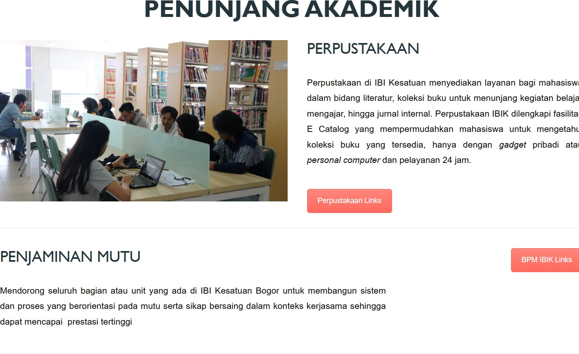 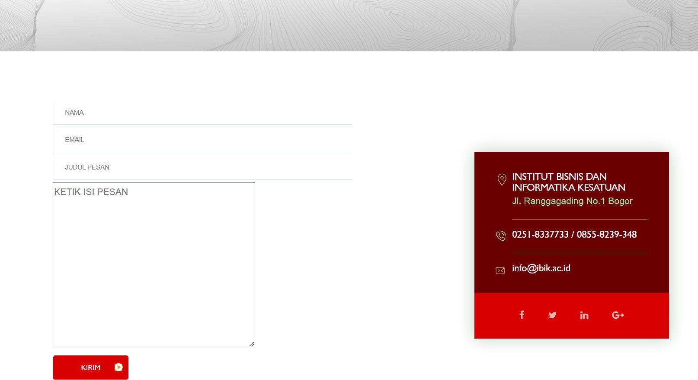

Fig. 4. *Facilities page*

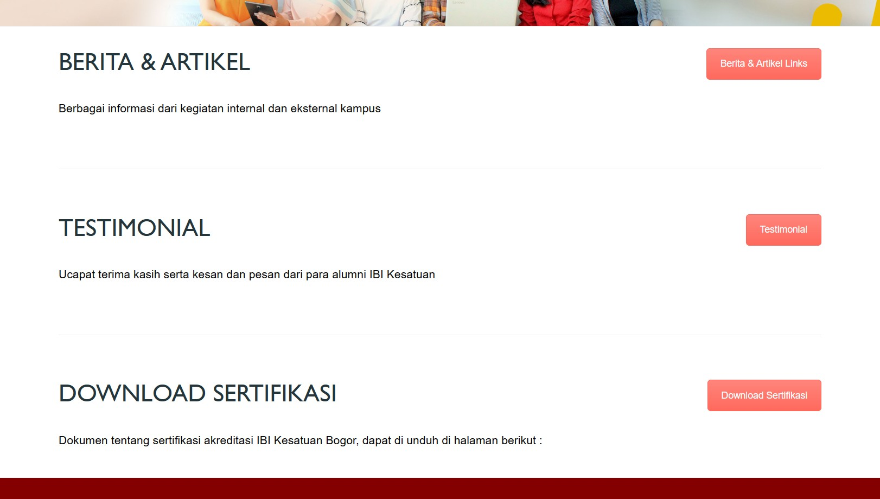Figure 4 there is an explanation of supporting facilities available on the campus.

Fig. 7. *Contact institutes page*

Figure 7 contains a column to leave a message to the institution, which makes it easier for users to directly send a message.

Fig. 5. *Academic information page*

Figure 5 there are icons for articles & news, testimonials, and a place to download certificates obtained by someone.

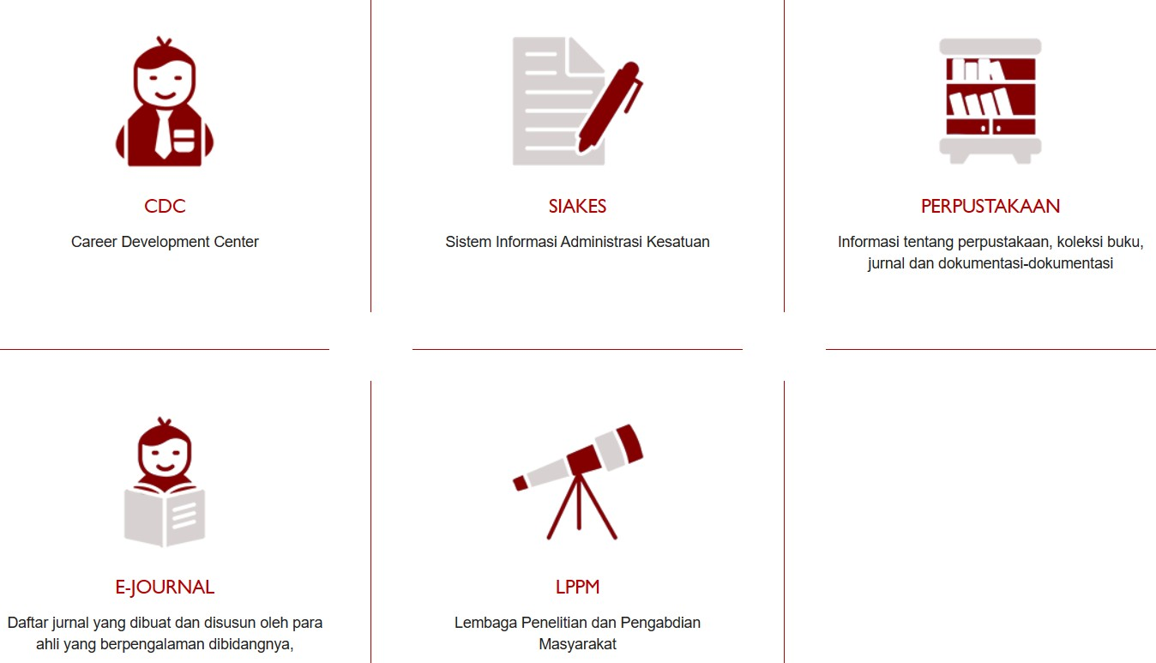

Fig. 6. *Links page*

Figure 6 there are links including the Career Development Center, the Kesatuan Administration Information System, information about the library, book collections, journals, and documentation, a list of journals created and compiled by experienced experts in their fields, and the Research and Community Service Institute that can be accessed for free.

1. RESEARCH METHODOLOGY
2. Research Methods

This research uses the system usability scale/SUS method, which is a survey system to determine the perception of the usefulness of a software [1]. The SUS system was created by John Brooke in 1986 to test office electronic systems. The SUS System is a survey containing 10 questions where participants can choose a score between 1-5 (where 1 = strongly disagree and 5 = strongly agree) to be answered based on the participants’ opinions of the product or feature being tested. Before the SUS test is conducted, the researcher must first conduct validity and reliability tests.

1. Research Questionnaire

These are the questions asked within the questionnaire: Table 1. SUS survey questions

|  |  |
| --- | --- |
| SUS | |
| Code | Question |
| Q1 | How easy is it to use this website based on the menu structure presented? |
| Q2 | How easy is writing on this website to read and understand? |
| Q3 | How easy is it to find contact information on this website? |
| Q4 | How suitable is the composition of the colors on this website to help ease the use of the website? |
| Q5 | How easy is it to use this website based on the menu structure presented? |
| Q6 | How consistent is the screen display on this website for each menu that is presented? |
| Q7 | How complete is the information presented on this |

of Crombach Alpha test is around greater than 0,7 and less than 0,9.

|  |  |
| --- | --- |
|  | website? |
| Q8 | How easy is it to use this website to get the information you need? |
| Q9 | How easy is it to use this website to get the latest information? |
| Q10 | How quickly the website manager responds to questions asked by users |

Reliability test using Crombach Alpha test is done using formula:

1. Research Instruments
   1. Validity Test

Research results are declared valid if data correctly represent the actual value tested [2]. Valid instrument means that the measurement methods used to collect data is valid. Validity test is conducted with Expert Review and Product-Moment Coefficient. Expert Review is a test conducted by experts to give opinions to determine instruments’ validity, whereas Product-Moment Coefficient is conducted using equation:



Fig. 8. Product-Moment Coefficient Formula r = correlation coefficient

n - number of respondents

xi = score of every item on instruments yi = score of every item on criteria

After getting the coefficient of correlation, validity is determined by comparing t(count) with t(table), where t(table) is calculated according to research significance, which is 5% or 0,05 on this research. A point is valid if t(count)>t(table). t(count) is calculated using formula:



Fig. 9. t(count) formula r = coefficient of correlation

n = number of respondents t = value of t(count)

* 1. Reliability Test

Research is called reliable if data is similar within a different time span [2], which means there is little to no difference in data value during a period of time. Reliability test is conducted using Crombach Alpha test which is useful to research questionnaire data[2]. The range

Fig. 10. Crombach Alpha test formula ri = Crombach Alpha coefficient of reliability k = amount of items

si2 = variance of each item st2 = total variance

Whereas variance of items and total variance is calculated using formula:

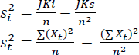

Fig. 11. Variance formulas si2 = variance of each item

st2 = total variance

JKi = sum of all item scores squared JKs = sum of all subjects squared

n = number of respondents Xt = total score

1. RESULT AND DISCUSSION

In this study using data as much as 50 respondents who are using the IBI Kesatuan website. Respondents will answer the 10 questions given. The data collection method used was a survey using the SUS questionnaire. The questionnaire was given to the respondents, where the respondents were asked to give a score to each question on the SUS questionnaire.

Table 2. SUS Score Interpretation

|  |  |  |
| --- | --- | --- |
| **No.** | **Score Interpretation** | **Score** |
| 1 | Strongly disagree | 1 |
| 2 | Disagree | 2 |
| 3 | Neutral | 3 |
| 4 | Agree | 4 |
| 5 | Strongly agree | 5 |

The SUS technique is a usability assessment method using a 5-point Likert scale[10]. The scale consists of five possible response choices, namely Strongly Disagree, Disagree, Neutral, Agree and Strongly Agree, each of which is associated with a predetermined number of points from 1 to 5.

1. *Validity test*

In the validity test, a 5% significance level was used with a sample of 50 participants to obtain a panel r-value of

0.28. The researcher chose a value roughly equal to the number of respondents. The validity of an entry is considered confirmed if the calculated r-value is greater than the 0.28 table r-value, while it is considered invalid if the r-value is less than the r-value of the board. This information is presented in the table below.

Table 3. Validity Test Results

|  |  |  |  |
| --- | --- | --- | --- |
| **Items** | **Count** | ***r* Table** | **Information** |
| Q1 | 0,404255 | 0,28 | Valid |
| Q2 | 0,377259 | 0,28 | Valid |
| Q3 | 0,376886 | 0,28 | Valid |
| Q4 | 0,395962 | 0,28 | Valid |
| Q5 | 0,400093 | 0,28 | Valid |
| Q6 | 0,401431 | 0,28 | Valid |
| Q7 | 0,425017 | 0,28 | Valid |
| Q8 | 0,441867 | 0,28 | Valid |
| Q9 | 0,441626 | 0,28 | Valid |
| Q10 | 0,442546 | 0,28 | Valid |

According to the validity test results, it was observed that the calculated value of r for all items (Q1-Q10) was greater than the r table value of 0.28 with a significance level of 5%. As a result, it can be concluded that all the items are valid and meet the validity standards for measuring the intended variable, and are suitable for data collection in research.

1. *Reliability Test*

In this study, the test Reliability is performed together on each question and uses Cronbach's Alpha method (a). Results measurement gets a consistent value when done twice or more (Suryabrata, 1998)[08].

Table 4. Reliability Test Results

|  |  |  |
| --- | --- | --- |
| **Reference Value** | **Crombach's Alpha value** | **Conclusion** |
| 0,7 | 1,103878654 | Reliable |

The Cronbach's Alpha value obtained > from the minimum standard value of reliability, which is 0.6, so it can be concluded that the SUS questionnaire is reliable and adequate for use in measuring the usability of the IBI Kesatuan website.

1. *System Usability Scale Test (SUS)*

SUS is distinguished by many areas of use, simplicity and speed of use for both practitioners and participants (Bangor et al. 2008)[07]. SUS provides an overview of the product's usefulness with easy-to-understand symbols. Although this is a 100-point scale, it does not give an absolute rating of a product's usefulness. The results of the usability assessment of the IBI Kesatuan website in this study were obtained by calculating the System Usability Scale (SUS) score for each respondent.

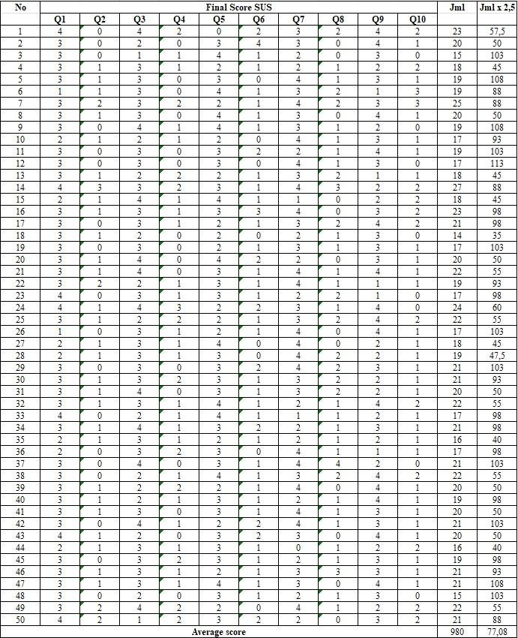

Fig. 12. SUS Response Data

The usability test results above are obtained by following the step by step instructions to calculate the System Usability Scale (SUS). The score given by the respondent for each statement is converted into a number from 1 to 5, where 1 means strongly disagree and 5 means strongly agree, by subtracting 5 even numbered statements and 1 for odd numbered statements. The converted data is 980, which is then multiplied by 2.5 and divided by the number of respondents, namely 50. The resulting score is 77.08, which is rounded to 77. Therefore, the SUS Overall Score formula for respondents is :

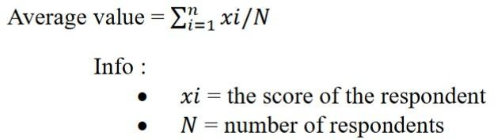

Fig. 13. SUS Score Formula

Based on the research results, it is found that the SUS questionnaire is a valid and reliable tool for measuring the usability of the IBI Kesatuan website. The validity test shows that all items in the questionnaire are valid, while the

reliability test using the Cronbach's Alpha method produces a value that is greater than the minimum standard value of reliability which indicates that the questionnaire is reliable.

The overall SUS score obtained from the respondents was 77, which indicates that the use of the Unitary IBI website is rated "good" based on Grade interpretation. Adjective interpretation also supports this, as scores fall within the range of scores normally considered "good" (70-79).

Furthermore, Acceptable Interpretation indicates that the SUS score is above the minimum acceptable score of 68[09], indicating that the website is acceptable for use. the interpretation of the Net Promoter Score (NPS) indicates that the website has a positive NPS, because the SUS score is within the range of scores that would normally result in a positive NPS. which can be seen in the image below:

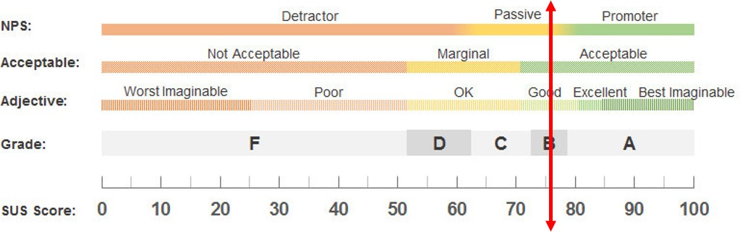

Fig. 14. SUS Score Interpretation

1. CONCLUSION

The System Usability Scale (SUS) method is a reliable and widely used tool for measuring the usability of digital products. However, it is important to consider the potential impact of users' experiences on the results obtained from the SUS questionnaire. By taking this into account, designers and researchers can gain a more accurate understanding of a product's usability and make informed decisions to improve it. By collecting data from respondents who have used the IBI Kesatuan website, the SUS method can be used to measure the usability level of the website. The score obtained from the respondents' responses is 77,08 which can be used to identify the strengths and weaknesses of the website in terms of usability. This information may be used to improve website design, content, navigation and other elements to enhance user experience and satisfaction.

REFERENCES

1. “Apa Itu Website? Simak Pengertian, Jenis & Manfaatnya!,” *Niagahoster Blog*, Jan. 22, 2018. https://[www.niagahoster.co.id/blog/pengertian-website/](http://www.niagahoster.co.id/blog/pengertian-website/)
2. “Asosiasi Penyelenggara Jasa Internet Indonesia,”

*apjii.or.id*.

https://apjii.or.id/berita/d/survei-apjii-pengguna-internet-di-i ndonesia-tembus-215-juta-orang

1. T. Ismi, “Mengenal Interaction Design, Komponen User Experience yang Tak Kalah Penting,” *Glints Blog*, Sep.

02, 2020.

https://glints.com/id/lowongan/interaction-design-adalah/#. ZFJbQWgza3B (accessed May 03, 2023).

1. “Apa itu Interaction Design?,” *IDS | International Design School*, Dec. 05, 2017.

https://idseducation.com/apa-itu-interaction-design/#:~:text

=Definisi%20Interaction%20Design.%20Interaction%20des ign%20adalah%20struktur%20dan (accessed May 03, 2023).

1. H. Alathas, “Bagaimana Mengukur kebergunaan produk dengan System Usability Scale (SUS) Score,” *Medium*, Oct. 20, 2018.

https://medium.com/kelasux/bagaimana-mengukur-kebergu naan-produk-dengan-system-usability-scale-sus-score-2d68 43ca780a

1. M. L. L. Usman and M. A. Gustalika, “Pengujian Validitas dan Reliabilitas System Usability Scale (SUS) Untuk Perangkat Smartphone,” *Jurnal Ecotipe (Electronic, Control, Telecommunication, Information, and Power Engineering)*, vol. 9, no. 1, pp. 19–24, Mar. 2022, doi: https://doi.org/10.33019/jurnalecotipe.v9i1.2805.
2. K. S. Taber, “The Use of Cronbach’s Alpha When Developing and Reporting Research Instruments in Science Education,” *Research in Science Education*, vol. 48, no. 6, pp. 1273–1296, Jun. 2018, doi: https://doi.org/10.1007/s11165-016-9602-2.
3. keith s. taber, “the use of cronbach’s alpha when developing and reporting research instruments in science education ,” Jun. 07, 2017.

https://link.springer.com/content/pdf/10.1007/s11165-016-9 602-2.pdf?pdf=button (accessed Apr. 23, 2023).

1. J. R. Lewis, “The System Usability Scale: Past, Present, and Future,” *International Journal of Human–Computer Interaction*, vol. 34, no. 7, pp. 577–590, Mar. 2018, doi: https://doi.org/10.1080/10447318.2018.1455307.

[10] K. Finstad, “response interpolation and scale sensivity : evidence againts 5-point scales,” Nov. 2009. https://[www.researchgate.net/profile/Kraig-Finstad/publicati](http://www.researchgate.net/profile/Kraig-Finstad/publicati) on/265929744_Response_Interpolation_and_Scale_Sensitiv ity_Evidence_Against_5-Point_Scales/links/5b23fe4aaca27 2277fb27252/Response-Interpolation-and-Scale-Sensitivity- Evidence-Against-5-Point-Scales.pdf (accessed Apr. 27, 2023).